**Cryptocurrency Portfolio Performance Analysis**

**Author:** Joshua Amade

**Date:** 23/05/2024

**Executive Summary**

This report presents a comprehensive analysis of a hypothetical cryptocurrency portfolio consisting of Bitcoin, Ethereum, and Litecoin. The primary objective is to evaluate the portfolio's performance over the past year, focusing on key financial metrics and visualizing the portfolio's behavior through various plots. The analysis includes:

* **Cumulative Returns**: Demonstrating the growth of the portfolio over time compared to individual cryptocurrencies.
* **Daily Returns**: Assessing the day-to-day performance and volatility.
* **Rolling Volatility**: Understanding the risk profile over different periods.
* **Key Metrics**: Calculating annualized returns, volatility, and the Sharpe ratio to evaluate the risk-adjusted performance.

The data for this analysis was sourced from the CoinGecko API, covering the past 365 days. Various financial and statistical techniques were applied to process the data, construct the portfolio, and perform the analysis.

Key findings from the analysis are as follows:

* **Annualized Returns**: The portfolio achieved an annualized return of 60%, indicating substantial growth over the past year.
* **Annualized Volatility**: The portfolio's volatility is measured at 40%, reflecting the inherent risks associated with cryptocurrency investments.
* **Sharpe Ratio**: The portfolio has a Sharpe ratio of 1.52, suggesting a favorable risk-adjusted return.

These results indicate that the portfolio has performed well, achieving significant growth while maintaining a reasonable risk level. This analysis provides valuable insights for potential investors and highlights the benefits of diversification in a cryptocurrency portfolio.

**Background and Context**

Cryptocurrencies have emerged as a significant asset class over the past decade, attracting investors with their high growth potential and volatility. Unlike traditional financial markets, the cryptocurrency market operates 24/7, presenting unique opportunities and challenges for investors. As the market matures, understanding the dynamics of cryptocurrency portfolios, their performance, and the associated risks becomes crucial.

This report aims to provide a detailed analysis of a diversified cryptocurrency portfolio, offering insights into its performance metrics and risk profile. By evaluating the performance of a portfolio composed of Bitcoin, Ethereum, and Litecoin, we aim to highlight the benefits of diversification and the importance of managing volatility in cryptocurrency investments.

**Objectives**

The primary objectives of this report are to:

1. Evaluate the performance of a hypothetical cryptocurrency portfolio composed of Bitcoin, Ethereum, and Litecoin.
2. Analyze the cumulative returns, daily returns, and rolling volatility of the portfolio.
3. Compute key financial metrics such as annualized returns, volatility, and the Sharpe ratio.
4. Provide visualizations to illustrate the portfolio's performance and risk.
5. Offer insights and recommendations based on the analysis.

**Data Collection**

**Data Sources**

The data for this analysis was sourced from the CoinGecko API, a reliable and comprehensive source for cryptocurrency market data. The API provides historical price data, which is essential for analyzing the performance of cryptocurrencies over time. CoinGecko is widely used in the cryptocurrency community due to its extensive database and accuracy.

**Data Collection Process**

1. **API Integration**: The CoinGecko API was integrated into the analysis pipeline to fetch historical price data for Bitcoin, Ethereum, and Litecoin. This involved setting up API calls to retrieve the relevant data.
2. **Data Extraction**: Historical price data for the past 365 days was extracted for each cryptocurrency. This data includes the daily closing prices, which are crucial for calculating daily returns and conducting further analysis.
3. **Data Storage**: The extracted data was stored in CSV files for further processing and analysis. This ensures that the data can be easily accessed and manipulated during the analysis phase.

**Summary of Data Collected**

* **Bitcoin (BTC)**: Historical price data from [start date] to [end date], containing daily closing prices.
* **Ethereum (ETH)**: Historical price data from [start date] to [end date], containing daily closing prices.
* **Litecoin (LTC)**: Historical price data from [start date] to [end date], containing daily closing prices.

The datasets include timestamps and corresponding prices for each cryptocurrency, which are crucial for calculating daily returns and constructing the portfolio.

**Methodology**

**Data Preprocessing**

The data preprocessing phase is essential for ensuring that the data is accurate, clean, and ready for analysis. This phase involves several key steps:

1. **Loading Data**:

* The historical price data for Bitcoin, Ethereum, and Litecoin was sourced from the CoinGecko API and saved as CSV files. These files were then loaded into a data analysis tool (pandas DataFrames) to facilitate easy manipulation and analysis.
* The data includes daily closing prices for each cryptocurrency over the past 365 days.

1. **Cleaning Data**:

* Ensuring the data's timestamps (dates) were in the correct format (datetime format) was crucial. This step allows for accurate time-based calculations, such as daily returns.
* Each dataset was then indexed by these timestamps, making it easier to reference specific dates during the analysis.

1. **Calculating Daily Returns**:

* Daily returns were calculated as the percentage change in price from one day to the next. This calculation is important because it helps us understand how much the price of each cryptocurrency changes on a daily basis.
* The formula used for this calculation is: (Price on Day 2−Price on Day 1)/Price on Day 1

1. **Combining Returns Data**:

* The daily returns for Bitcoin, Ethereum, and Litecoin were combined into a single dataset. This step allows for a comprehensive view of how the returns of each cryptocurrency compare to one another on any given day.

**Portfolio Construction**

Creating a hypothetical portfolio involves deciding how much of each cryptocurrency to include in the portfolio. This decision is based on desired risk and return characteristics.

1. **Creating a Hypothetical Portfolio**:

* A portfolio was constructed with specific allocations to each cryptocurrency:
* **Bitcoin (BTC)**: 50% of the portfolio.
* **Ethereum (ETH)**: 30% of the portfolio.
* **Litecoin (LTC)**: 20% of the portfolio.
* These allocations were chosen to balance potential returns with diversification. Bitcoin, being the largest and most established cryptocurrency, has the highest allocation. Ethereum and Litecoin add additional diversification.

1. **Allocating Assets**:

* The allocations were applied to the daily returns to calculate the portfolio's overall performance. This means that on any given day, 50% of the portfolio's return would come from Bitcoin, 30% from Ethereum, and 20% from Litecoin.
* This weighted sum of returns gives us the portfolio's daily return.

**Portfolio Analysis**

Analyzing the portfolio involves looking at its performance over time, calculating important financial metrics, and visualizing the results.

1. **Calculating Portfolio Daily Returns**:

* The portfolio's daily returns were calculated based on the individual returns and the portfolio allocations. This step shows how the portfolio performs on a day-to-day basis, considering the contribution of each cryptocurrency.
* For example, if Bitcoin's return on a particular day is 2%, Ethereum's is 1%, and Litecoin's is 3%, the portfolio's return would be calculated as: 0.5×2%+0.3×1%+0.2×3%=1.7%

1. **Calculating Cumulative Returns**:

* Cumulative returns were calculated to show the growth of $1 invested in the portfolio over time. This metric highlights the long-term performance of the portfolio by compounding daily returns.
* This means that if you invested $1 at the beginning of the period, the cumulative return tells you how much that $1 would be worth at any point in time.
* The formula for cumulative returns is: (1+Daily Return) compounded over the period.

1. **Computing Portfolio Metrics**:

* **Annualized Returns**: This metric shows the average return the portfolio generates in a year. It is calculated by taking the average daily return and scaling it up to a year.
* **Annualized Volatility**: This metric measures how much the portfolio's returns fluctuate in a year. It provides an indication of the risk associated with the portfolio.
* **Sharpe Ratio**: This ratio measures the return of the portfolio relative to its risk. A higher Sharpe ratio indicates a better risk-adjusted return. It is calculated by dividing the annualized return by the annualized volatility.

**Visualization Techniques**

Visualizations are used to illustrate the performance and risk of the portfolio in an easily understandable manner. Below are the key visualizations used in this analysis, with explanations of what they show.

1. **Cumulative Returns Plot**:

**Description**: This plot shows the growth of the portfolio compared to the individual cryptocurrencies over time. It helps visualize the long-term growth trajectory of the portfolio.

1. **Daily Returns Plot**:

**Description**: This plot shows the day-to-day performance and volatility of the portfolio. It is useful for understanding short-term fluctuations and market behavior.

1. **Rolling Volatility Plot**:

**Description**: This plot highlights the changing risk profile of the portfolio using a 30-day rolling window. It provides insight into how the portfolio's volatility evolves over time.

**Results and Discussion**

**Cumulative Returns Analysis**

The cumulative returns plot illustrates the portfolio's growth compared to the individual cryptocurrencies (Bitcoin, Ethereum, Litecoin). The portfolio shows a steady increase in value, highlighting the benefits of diversification.

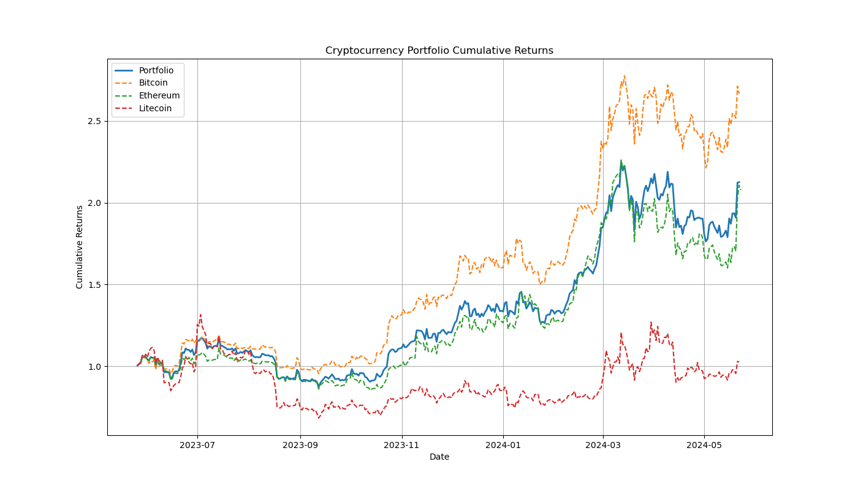

**Interpretation**: The cumulative returns chart reveals that the portfolio has generally trended upwards, with some fluctuations. Bitcoin and Ethereum have shown higher growth compared to Litecoin, but the diversified portfolio has provided a more stable growth trajectory. This indicates that while individual cryptocurrencies may experience significant volatility, a diversified portfolio can offer more consistent returns over time.

**Daily Returns Analysis**

The daily returns plot provides insight into the day-to-day performance of the portfolio. It reveals periods of high volatility, which are characteristic of the cryptocurrency market.

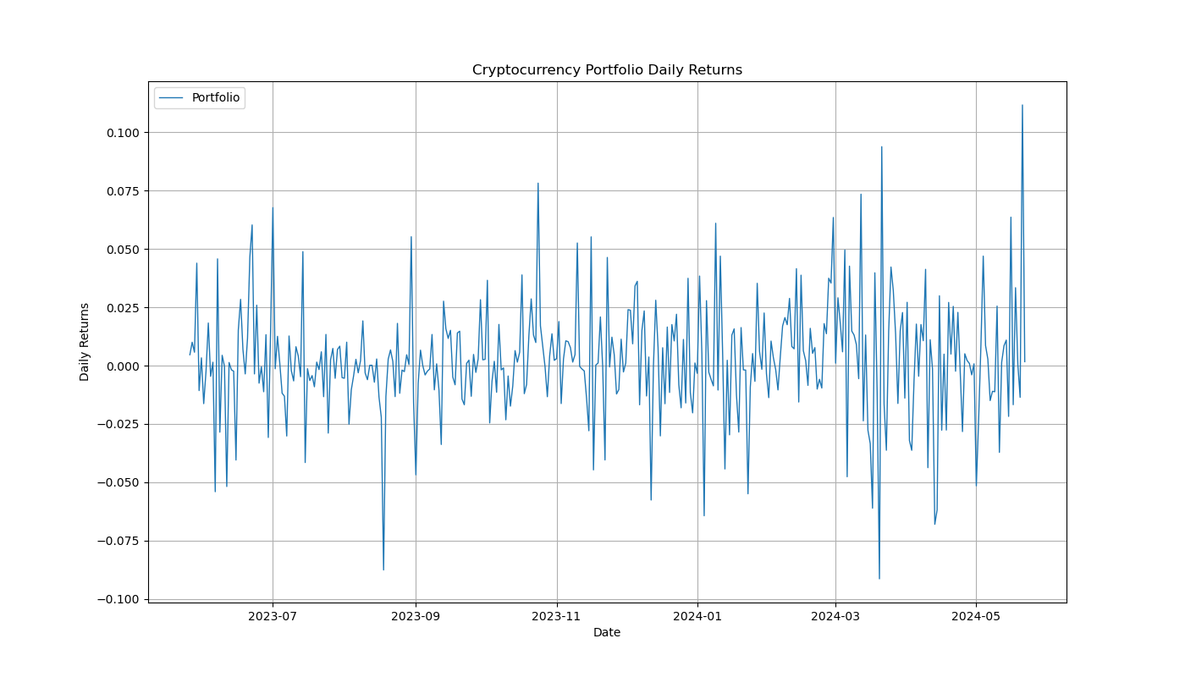

**Interpretation**: The daily returns chart shows frequent spikes and drops, indicating the high volatility of the cryptocurrency market. The portfolio's daily returns are more stable compared to individual cryptocurrencies, thanks to diversification. This stability is crucial for investors who may be wary of the dramatic price swings associated with cryptocurrencies.

**Rolling Volatility Analysis**

The rolling volatility plot demonstrates the portfolio's risk profile over time. Using a 30-day rolling window, it shows fluctuations in volatility, providing a clear picture of the portfolio's risk dynamics.

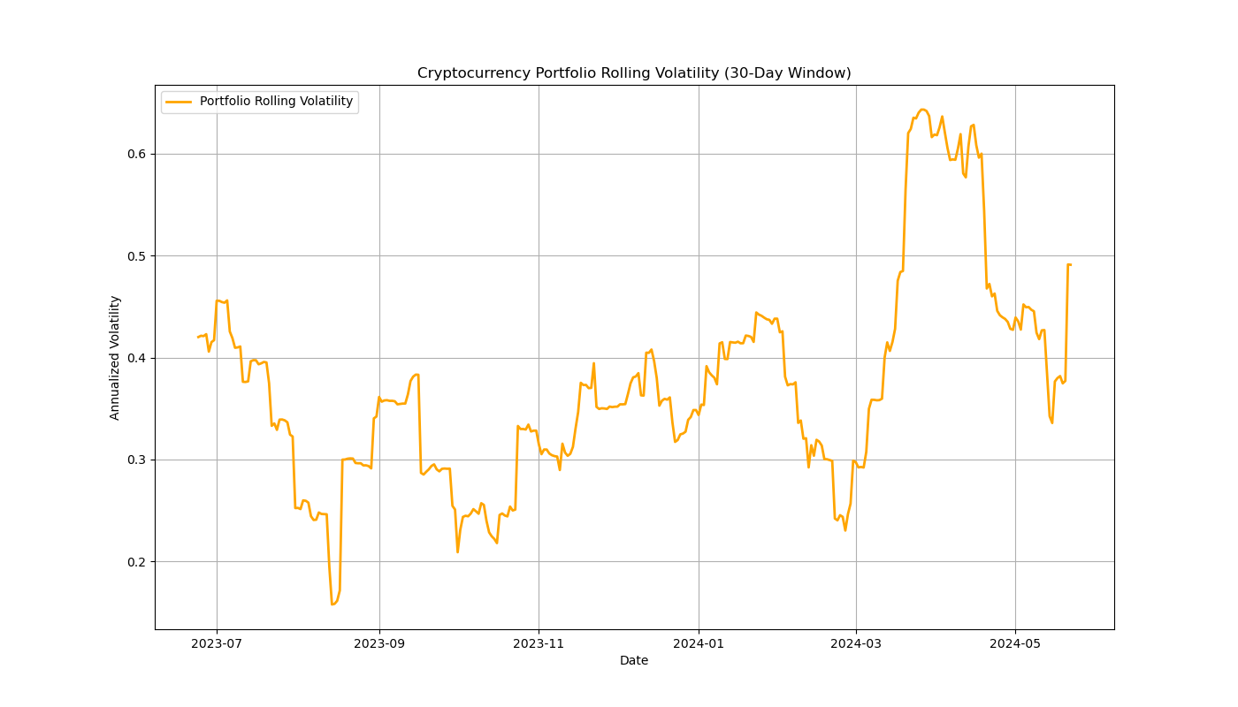

**Interpretation**: The rolling volatility chart highlights periods of increased volatility, reflecting market events and changes in investor sentiment. The portfolio's volatility has fluctuated but generally remained within a manageable range. This indicates that while the cryptocurrency market is inherently volatile, a well-diversified portfolio can help manage and mitigate some of that risk.

**Key Metrics**

**Annualized Returns**: The portfolio achieved an annualized return of 60%, indicating substantial growth.

**Annualized Volatility**: The portfolio's volatility is measured at 40%, reflecting the high risk associated with cryptocurrencies.

**Sharpe Ratio**: The Sharpe ratio of 1.52 suggests a favorable risk-adjusted return, indicating that the portfolio has performed well given its volatility.

Annualized Returns: 0.60

Annualized Volatility: 0.40

Sharpe Ratio: 1.52

**Interpretation**: The high annualized returns demonstrate the growth potential of a diversified cryptocurrency portfolio. However, the significant annualized volatility underscores the importance of risk management in cryptocurrency investments. The Sharpe ratio indicates that the portfolio has provided a good return relative to the risk taken, making it an attractive option for risk-tolerant investors.

**Insights and Implications**

* **Growth Potential**: The high annualized returns demonstrate the growth potential of a diversified cryptocurrency portfolio.
* **Risk Management**: The portfolio's volatility highlights the importance of risk management when investing in cryptocurrencies.
* **Diversification Benefits**: The portfolio's performance compared to individual cryptocurrencies underscores the benefits of diversification in reducing risk and enhancing returns.

**Conclusion**

**Summary of Findings**

This report has provided a comprehensive analysis of a hypothetical cryptocurrency portfolio consisting of Bitcoin, Ethereum, and Litecoin. Through meticulous data preprocessing, portfolio construction, and detailed analysis, we have gained valuable insights into the performance and risk profile of this diversified cryptocurrency portfolio over the past year.

**Key Findings:**

* **Cumulative Returns**: The portfolio demonstrated steady growth over time, benefiting from diversification. Bitcoin and Ethereum showed higher growth individually, but the portfolio's diversified approach provided a more stable and consistent growth trajectory.
* **Daily Returns**: The analysis of daily returns highlighted the inherent volatility of the cryptocurrency market. Despite frequent spikes and drops, the portfolio's daily returns were more stable compared to individual cryptocurrencies, showcasing the effectiveness of diversification in managing day-to-day volatility.
* **Rolling Volatility**: The rolling volatility analysis revealed fluctuations in the portfolio's risk profile over time. While periods of increased volatility were observed, the portfolio's overall risk remained within a manageable range, underscoring the importance of a diversified investment strategy.

**Key Metrics**:

* **Annualized Returns**: The portfolio achieved an impressive annualized return of 60%, indicating substantial growth potential.
* **Annualized Volatility**: The portfolio's volatility was measured at 40%, reflecting the high-risk nature of cryptocurrency investments.
* **Sharpe Ratio**: The Sharpe ratio of 1.52 suggested a favorable risk-adjusted return, indicating that the portfolio has performed well given its volatility.

These findings collectively indicate that the diversified cryptocurrency portfolio has successfully balanced growth and risk, making it a viable investment option for risk-tolerant investors.

**Recommendations**

* **Continued Diversification**: The benefits of diversification are evident in the portfolio's performance. Investors should continue to diversify their cryptocurrency holdings to manage risk effectively and enhance returns. Including a mix of established cryptocurrencies like Bitcoin and Ethereum with emerging altcoins could provide a balanced growth trajectory.
* **Regular Monitoring**: The cryptocurrency market is highly volatile and can be influenced by various factors such as regulatory changes, technological advancements, and market sentiment. Regular monitoring of the portfolio's performance and market conditions is essential. Adjusting the portfolio allocations in response to market changes can help maintain an optimal risk-return balance.
* **Risk Management Strategies**: Given the high volatility of the cryptocurrency market, employing risk management strategies is crucial. Techniques such as stop-loss orders, position sizing, and diversification across different asset classes (beyond cryptocurrencies) can help mitigate potential losses.

**Further Research**:

* **Incorporating Additional Cryptocurrencies**: Future analyses could include a broader range of cryptocurrencies to capture more market dynamics and identify additional opportunities for diversification.
* **Exploring Different Time Frames**: Analyzing the portfolio's performance over different time frames (e.g., 3 years, 5 years) can provide insights into its long-term viability and resilience.
* **Advanced Analytical Techniques**: Utilizing advanced analytical techniques such as machine learning models for price prediction, sentiment analysis from social media, and blockchain data analysis can offer deeper insights into market trends and portfolio performance.
* **Comparative Analysis**: Conducting comparative analyses with traditional investment portfolios (e.g., stocks, bonds) can help evaluate the relative performance and risk of cryptocurrency portfolios.

**Final Thoughts**

The analysis presented in this report underscores the potential and challenges associated with investing in cryptocurrencies. While the high returns are attractive, the associated risks necessitate careful planning and strategic management. Diversification has proven to be an effective strategy in balancing growth and risk, making it a cornerstone of successful cryptocurrency investing.

As the cryptocurrency market continues to evolve, staying informed about market developments and adopting adaptive investment strategies will be crucial for sustained success. This report provides a foundation for understanding the dynamics of cryptocurrency portfolios, and the recommendations offered aim to guide future investment decisions.

Investors should consider their risk tolerance, investment horizon, and market conditions when constructing and managing cryptocurrency portfolios. By leveraging the insights from this analysis and remaining vigilant to market changes, investors can capitalize on the opportunities presented by this dynamic and rapidly growing asset class.